DEV-OPS MSE-1
Name: Tanishque Baranwal
Roll no.: 2400290100317
Year: 3
Branch: CSE
Sec: E
1.Repo:https://github.com/tanishque-boop/github-skills-challenge
2. PR-1:https://github.com/tanishque-boop/github-skills-challenge/pull/1
3.Initial Coverage Test
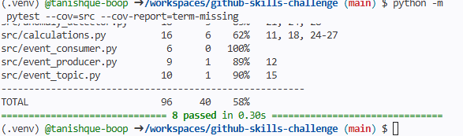
4.Workflows detected:
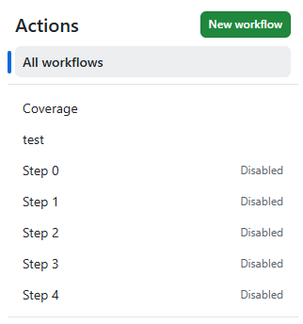
5.Both workflow failing
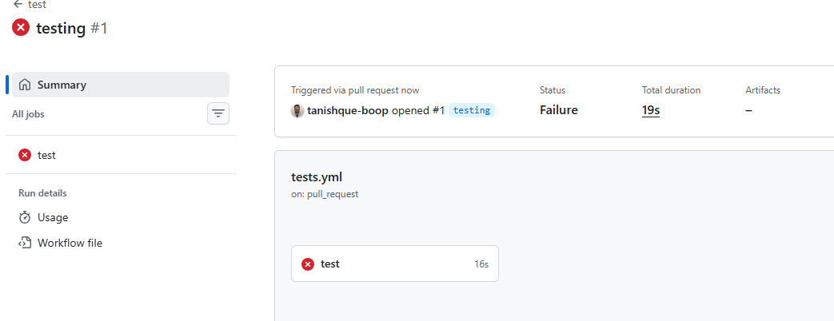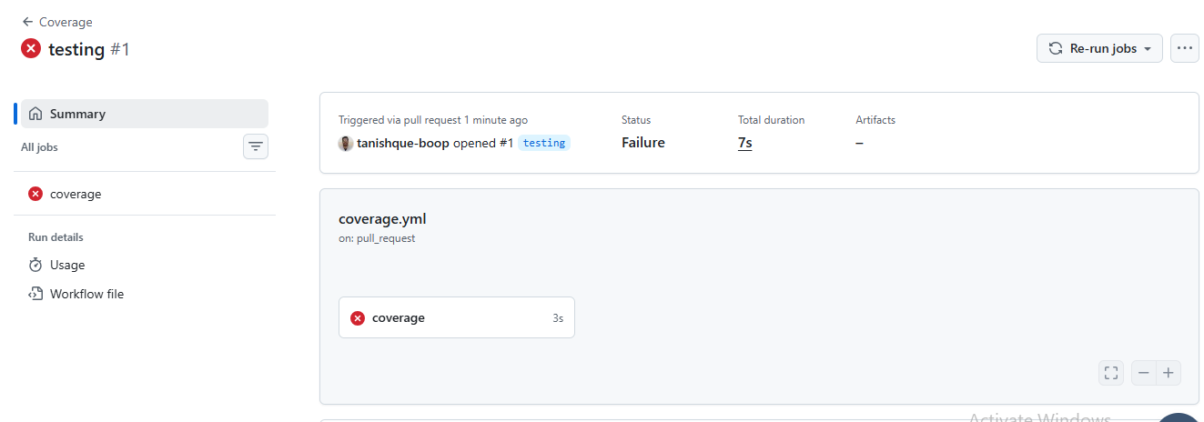
6.Working Files and Branch
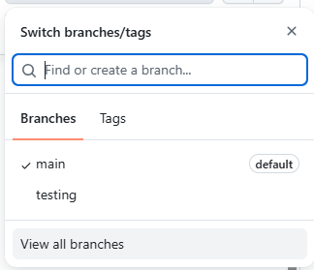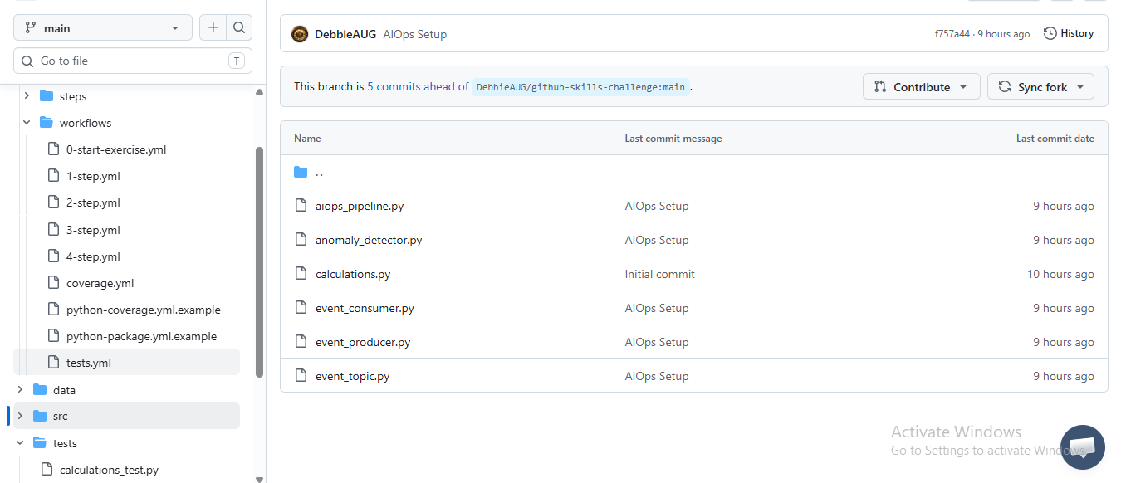
8.PR-2: https://github.com/tanishque-boop/github-skills-challenge/pull/1
9. Working Workflows:
